For changes to the authorship of manuscript, FUJD requires that all authors complete and sign this ‘Change of Authorship Request Form’. The affected author(s) must also sign this form as a way of consenting to the change(s) and agreeing to the new Author Contributions, Conflict of Interest and Acknowledgement Sections.

In accordance with the ICMJE Guidelines, when determining authorship, the following criteria should be observed:

* **Substantial contributions to the conception or design of the work; or the acquisition, analysis, or interpretation of data for the work; AND**
* **Drafting the work or revising it critically for important intellectual content; AND**
* **Final approval of the version to be published; AND**
* **Agreement to be accountable for all aspects of the work in ensuring that questions related to the accuracy or integrity of any part of the work are appropriately investigated and resolved.**

Contributors who meet fewer than all 4 of the above criteria for authorship should not be listed as authors, but they should be acknowledged (as per ICMJE Guidelines).

Please note that we cannot proceed until this issue has been resolved.

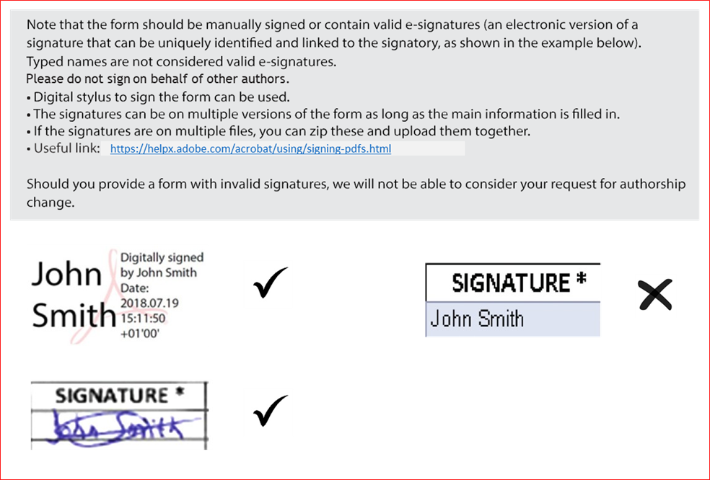

**Title of Manuscript:**

**Manuscript ID:**

1. **Current Authorship list, in the order shown on the manuscript. Please indicate the corresponding author with a \***

|  |  |  |  |
| --- | --- | --- | --- |
| **Current Author list** | **First name(s)** | **Family name** | **Email address** |
| **1st author** |  |  |  |
| **2nd author** |  |  |  |
| **3rd author** |  |  |  |
| **4th author** |  |  |  |
| **5th author** |  |  |  |
| **6th author** |  |  |  |

*Please insert new rows if needed*

1. Please provide an explanation for thechange in authorship **(including any reasons for removal from authorship list)**.
2. **Proposed new authorship list (including email addresses), in the order it should appear on the manuscript. Please indicate the corresponding author with a \***

|  |  |  |  |  |
| --- | --- | --- | --- | --- |
| **New Author list and order** | **First name(s)** | **Family name** | **Email address** | **Contribution of authors (please see our** [**authorship criteria**](https://fui.edu.pk/fujd/index.php/fujd/navigationMenu/view/Editorial-Policies)**)** |
| **1st author** |  |  |  |  |
| **2nd author** |  |  |  |  |
| **3rd author** |  |  |  |  |
| **4th author** |  |  |  |  |
| **5th author** |  |  |  |  |
| **6th author** |  |  |  |  |

*Please insert new rows if needed*

1. **All authors, unchanged, new and removed must sign this declaration.**

Only handwritten signatures are allowed.

Typed names in the signature box WILL NOT be accepted unless accompanied by an additional email confirmation from that co-author agreeing to the new author list and the explanation of changes outlined in Section 2. This email must come from the same email address assigned to that co-author in the above sections.

|  |  |  |  |
| --- | --- | --- | --- |
| **Author name (first name, last name)** | **Declaration** | **Signature (if typed please ensure confirmation via email is attached)** | **Date signed** |
|  | **I agree to the new authorship list and contributions shown above in section 3, for the reasons outlined in section 2.** |  |  |
|  | **I agree to the new authorship list and contributions shown above in section 3, for the reasons outlined in section 2.** |  |  |
|  | **I agree to the new authorship list and contributions shown above in section 3, for the reasons outlined in section 2.** |  |  |
|  | **I agree to the new authorship list and contributions shown above in section 3, for the reasons outlined in section 2.** |  |  |
|  | **I agree to the new authorship list and contributions shown above in section 3, for the reasons outlined in section 2.** |  |  |
|  | **I agree to the new authorship list and contributions shown above in section 3, for the reasons outlined in section 2.** |  |  |

**Current Author Contribution Statement:**

**New Author Contribution Statement:**

(If the statement currently in the Manuscript is correct, please leave the below blank)

**Current Conflict of Interest Statement:**

**New Conflict of Interest Statement:**

(If the statement currently in the Manuscript is correct, please leave the below blank)

**Current Acknowledgment Statement:**

**New Acknowledgment Statement:**

(If the statement currently in the Manuscript is correct, please leave the below blank)

**Please provide the final authors list in the order they should appear in the final publication**

Note that the final spelling and presentation of Author names (special characters, middle names, etc) will be as provided in the Manuscript.

|  |  |  |  |  |
| --- | --- | --- | --- | --- |
| **First name(s)** | **Surname** | **Email address** | **Signature** | **Date** |
|  |  |  |  |  |
|  |  |  |  |  |
|  |  |  |  |  |
|  |  |  |  |  |
|  |  |  |  |  |
|  |  |  |  |  |
|  |  |  |  |  |
|  |  |  |  |  |
|  |  |  |  |  |
|  |  |  |  |  |
|  |  |  |  |  |
|  |  |  |  |  |
|  |  |  |  |  |
|  |  |  |  |  |
|  |  |  |  |  |
|  |  |  |  |  |
|  |  |  |  |  |
|  |  |  |  |  |
|  |  |  |  |  |
|  |  |  |  |  |
|  |  |  |  |  |
|  |  |  |  |  |
|  |  |  |  |  |
|  |  |  |  |  |
|  |  |  |  |  |

*\* By signing this form you agree*

***a****) For your name to added to/removed from the manuscript,*

***b****) To the new Author Contribution, Conflict of Interest and Acknowledgment statements and*

***c****) To the final author’s list as listed in the form.*